1. What is Uganda’s direction from the Democratic Republic of Congo(DRC)?

…………………………………………………………………………………………………………………………………………………………………………………

1. Give any one reason why the top of mountain Rwenzori is not suitable for human settlement?

…………………………………………………………………………………………………………………………………………………………………………………

1. How is a head quarter important in every district in Uganda?

………………………………………………………………………………………………………………………………………………………………………………..

1. Mention any way the parent can help a school to overcome debts.

……………………………………………………………………………………………………………………………………………………………………………….

1. How do civil servants benefits from the work of Uganda Revenue Authority?

…………………………………………………………………………………………………………………………………………………………………………………

The diagram below represents a surplus budget. Study it and answer the questions that follow

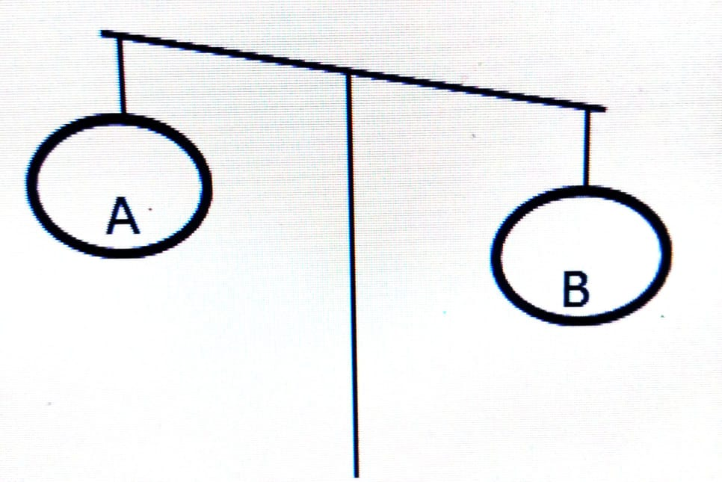

1. Name the part of the budget marked with letter B.

…………………………………………………………………………………………………………………………………………………………………………………

1. Give the reason why the above shown diagram is a surplus budget.

………………………………………………………………………………………………………………………………………………………………………………..

1. Mention any one advantage of making the above shown budget in the diagram.

…………………………………………………………………………………………………………………………………………………………………………………

1. Give any one way people can acquire citizenship in Uganda.

………………………………………………………………………………………………………………………………………………………………………………..

1. What title is given to a person who heads the Central Bank in Uganda?

………………………………………………………………………………………………………………………………………………………………………………..

1. Write any one problem that negatively affect health workers in offering their service to community.

…………………………………………………………………………………………………………………………………………………………………………………

1. Name the physical feature that was constructed to connect the Red sea to the Mediterranean Sea?

…………………………………………………………………………………………………………………………………………………………………………………

1. Name any one island country found in the Indian Ocean.

………………………………………………………………………………………………………………………………………………………………………………….

1. Give any one reason why it is not advisable to construct a school in a rift valley area.

……………………………………………………………………………………………………………………………………………………………………………………

1. Mention any one factor that favours water transport along some rivers of Africa.

………………………………………………………………………………………………………………………………………………………………………………….

1. State any one reason why the slopes of Mt Elgon are suitable for growing Arabica Coffee.

…………………………………………………………………………………………………………………………………………………………………………………….

1. Give any one way people in the Sahara desert adapt to the harsh climatic conditions.

……………………………………………………………………………………………………………………………………………………………………………………

1. Give any one evidence to show that trees in the equatorial rain forests compete for sunlight.

……………………………………………………………………………………………………………………………………………………………………………………..

1. How does human labour contribute to the economic development of a country?

……………………………………………………………………………………………………………………………………………………………………………………..

1. Name any one source of material for making the royal regalia below.

………………………………………………………………………………

1. Write down any one problem faced that was faced by the early man during Stone Age period.

……………………………………………………………………………………………………………………………………………………………………………………

1. State any one reason why Winston Churchill named Uganda as the Pearl of Africa.

……………………………………………………………………………………………………………………………………………………………………………………

1. What title is given to the head of the Executive organ of the government?

……………………………………………………………………………………………………………………………………………………………………………………

1. State any one cause of land conflicts in Uganda today.

…………………………………………………………………………………………………………………………………………………………………………………...

1. Why are televisions not commonly used in rural areas in Uganda?

……………………………………………………………………………………………………………………………………………………………………………………

1. Name any one trade item that the Portuguese obtained from India.

…………………………………………………………………………………………………………………………………………………………………………………….

1. Mention any one way Africans benefitted from the coming of Arabs.

……………………………………………………………………………………………………………………………………………………………………………………..

1. Name any one East Africa that was not colonized by the Germans.

………………………………………………………………………………………………………………………………………………………………………………………

1. Name any one state that was formed as a result of the Great trek.

……………………………………………………………………………………………………………………………………………………………………………………….

1. How is Kenana Irrigation scheme similar to Kilombero valley irrigation scheme?

……………………………………………………………………………………………………………………………………………………………………………………….

1. Give any one factor that attracts a big population in Northern Libya.

………………………………………………………………………………………………………………………………………………………………………………………..

1. State any one way Common Wealth of Nations assists member countries in promoting education.

……………………………………………………………………………………………………………………………………………………………………………………

1. Name any one right that would be violated if a child is denied food.

…………………………………………………………………………………………………………………………………………………………………………………….

1. How did the early explorers attract other to come to East Africa?

…………………………………………………………………………………………………………………………………………………………………………………..

1. Name political system where a number of political parties compete to gain control of the government.

…………………………………………………………………………………………………………………………………………………………………………………..

For questions 36- 40, answer either Christianity or Islam but not both

1. Either: Mention any one factor that leads to decline of friend ship among Christians.

……………………………………………………………………………………………………………………………………………………………………

Or: Mention any one factor that leads to decline of friend ship among Muslims.

……………………………………………………………………………………………………………………………………………………………………

1. Either: Why were believers in the African Traditional Religion not happy with the teachings of Jesus?

…………………………………………………………………………………………………………………………………………………………………….

Or: Why were believers in the African Traditional Religion not happy with the teachings of Prophet Muhammad?

………………………………………………………………………………………………………………………………………………………………………..

1. Either: How does a good Christian leader help the sick?

………………………………………………………………………………………………………………………………………………………………………..

Or: How does a good Muslim leader help the sick?

………………………………………………………………………………………………………………………………………………………………………..

1. Either: Give any one way Jesus brought happiness during the wedding at Cana.

……………………………………………………………………………………………………………………………………………………………………….

Or: Give any one way Prophet Muhammad brought happiness in Medina.

……………………………………………………………………………………………………………………………………………………………………….

1. Either: Why did God put Adam in the Garden of Eden?

………………………………………………………………………………………………………………………………………………………………………….

Or: Why did Allah put Adam in Paradise?

………………………………………………………………………………………………………………………………………………………………………

SECTION B

1. a) What title is given to the person who chairs Local Council five (LCV) meetings?

………………………………………………………………………………………………………………………………………………………………………………….

b) Give any two roles played by the Chairperson Local Council one (LCI).

i) ……………………………………………………………………………………………………………………………………………………………………………….

ii) ……………………………………………………………………………………………………………………………………………………………………………….

c) How does one become a Local Council one Chairperson?

…………………………………………………………………………………………………………………………………………………………………………………..

1. a) Name the political party that led Tanganyika to independence?

…………………………………………………………………………………………………………………………………………………………………………………..

b) Why were the foreign laws hated by the people of the people of East Africa?

……………………………………………………………………………………………………………………………………………………………………………….

c) How did the formation of political parties speed up the demand for independence?

………………………………………………………………………………………………………………………………………………………………………………..

d) Why did Tanganyika get independence before Uganda and Kenya?

…………………………………………………………………………………………………………………………………………………………………………………….

1. a) Name any country in Central Africa crossed by the Equator.

…………………………………………………………………………………………………………………………………………………………………………………..

b) Apart from the Equator, mention any two other lines of latitude that cross Africa.

i) ………………………………………………………………………………………………………………………………………………………………………………

ii) ……………………………………………………………………………………………………………………………………………………………………………..

c) Give any one importance of lines of latitude.

…………………………………………………………………………………………………………………………………………………………………………………….

1. a) Name the cash crop grown on Gezira Irrigation Scheme.

…………………………………………………………………………………………………………………………………………………………………………………….

b) Give any two benefits of the Gezira Irrigation Scheme to the people of Sudan.

i. …………………………………………………………………………………………………………………………………………………………………………………

ii …………………………………………………………………………………………………………………………………………………………………………………

c) Name any one source of the water for Gezira Irrigation Scheme.

……………………………………………………………………………………………………………………………………………………………………………………

1. Use the sketch map of Africa below and use it to answer questions that follow.

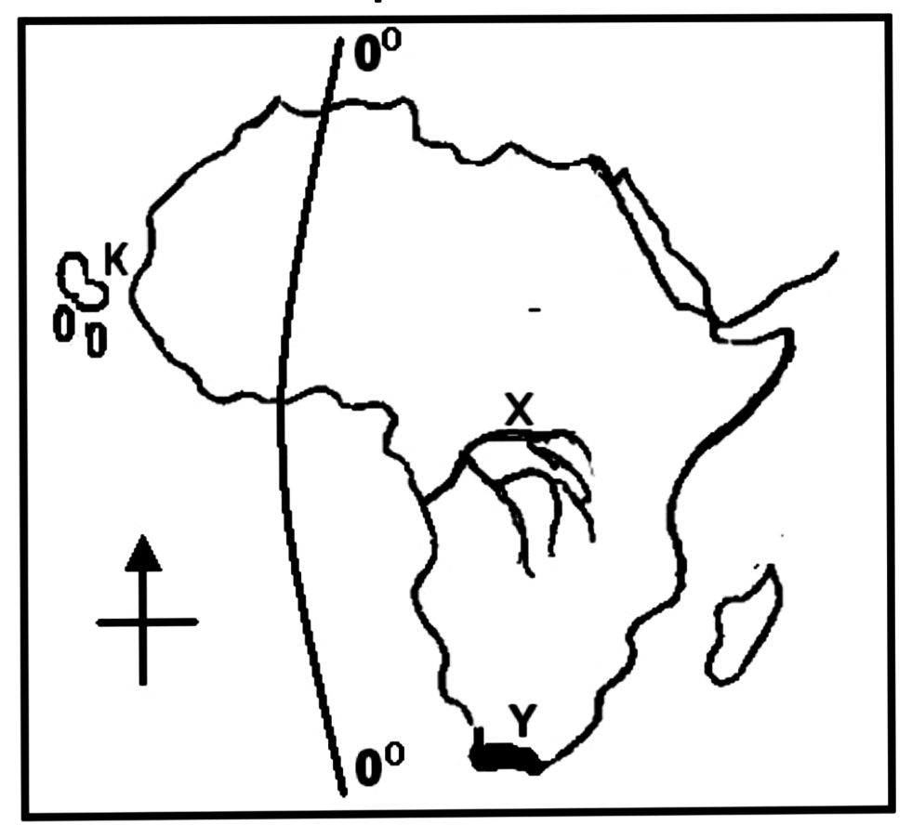

**L**

1. What name did the King of Portugal give the place marked Y after Bartholomew Diaz reached there?

……………………………………………………………………………………………………………………………………………………………………….

1. Name the island countries marked K and L.

K …………………………………………………………………………………………………………………………………………………………………

L …………………………………………………………………………………………………………………………………………………………………

1. Why does River marked with letter X carry a large volume of water to the Atlantic ocean?

………………………………………………………………………………………………………………………………………………………………………..

1. a) Name the British Governor of Uganda who exiled Kabaka Edward Muteesa II?

………………………………………………………………………………………………………………………………………………………………………………

b) State any one reason why Kabaka Edward Muteesa II was sent to exile by the above named governor?

…………………………………………………………………………………………………………………………………………………………………………..

1. Give any two ways how Ugandans reacted towards colonial administration.
2. ………………………………………………………………………………………………………………………………………………………………
3. ……………………………………………………………………………………………………………………………………………………………..
4. Study the diagram below and use it to answer questions that follow.

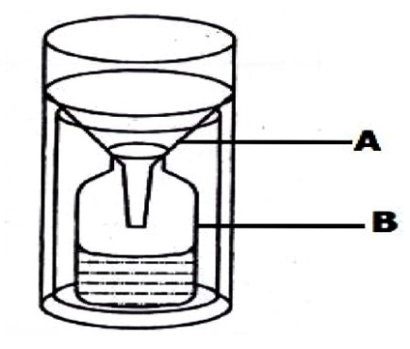

1. Name the instrument shown in the diagram.

………………………………………………………………………………………………………………………………………………………………………….

1. Name the parts marked with letters A and B

A ………………………………………………………………………………………………………………………………………………………………

B ……………………………………………………………………………………………………………………………………………………………….

1. State any one reason why the above named instrument is placed in an open flat area.

…………………………………………………………………………………………………………………………………………………………………………

1. a) What title is given to the Head of the Judiciary Arm of government in Uganda?

………………………………………………………………………………………………………………………………………………………………………………..

b) Give any one role of the Judiciary arm of government.

…………………………………………………………………………………………………………………………………………………………………………………

c) To which organ of government does each of these groups belong?

1. Police men …………………………………………………………………………………………………………………..
2. Members of Parliament …………………………………………………………………………………………………………………….
3. a) Name any two Pan Africanists who led their countries to independence in East Africa
4. …………………………………………………………………………………………………………………………………………………………………………
5. …………………………………………………………………………………………………………………………………………………………………………

b) State any two problems faced by the Pan Africanists in their struggle for independence.

1. …………………………………………………………………………………………………………………………………………………………………………
2. …………………………………………………………………………………………………………………………………………………………………………
3. a) Name the country in Africa where Apartheid Policy was popularly practiced.

…………………………………………………………………………………………………………………………………………………………………………………….

b) Give any two ways the above named policy was practiced.

i. ………………………………………………………………………………………………………………………………………………………………………………….

ii. …………………………………………………………………………………………………………………………………………………………………………………

c) State any one effect of the apartheid policy in the country named in (a) above.

…………………………………………………………………………………………………………………………………………………………………………………….

For questions 51- 55, answer either Christianity or Islam but not both alternatives in the same number.

1. Either:
2. What term is used to mean the short stories with hidden meanings as taught by Jesus?

……………………………………………………………………………………………………………………………………………………………………………..

1. Give any two examples of such stories named in (a) above
2. …………………………………………………………………………………………………………………………………………………………
3. ………………………………………………………………………………………………………………………………………………………….
4. State any one reason why Jesus used such stories named in (a) above

………………………………………………………………………………………………………………………………………………………………………

OR

1. What term is used to mean the traditional deeds and words of Prophet Muhammad?

……………………………………………………………………………………………………………………………………………………………………….

1. Mention any two reasons why Muslims follow the traditional teachings named in (a) above
2. ………………………………………………………………………………………………………………………………………………………….
3. …………………………………………………………………………………………………………………………………………………………..
4. What lessons do Muslims learn from these traditional deeds of Prophet Muhammad?

………………………………………………………………………………………………………………………………………………………………………

1. Either:
2. State any two ways churches have promoted the economic development of Uganda.
3. ………………………………………………………………………………………………………………………………………………………….
4. ………………………………………………………………………………………………………………………………………………………….
5. Give any two challenges that churches face in their providing their service to Uganda.
6. …………………………………………………………………………………………………………………………………………………………
7. ………………………………………………………………………………………………………………………………………………………….

OR

1. State any two ways mosques have promoted the economic development of Uganda.
2. ……………………………………………………………………………………………………………………………………………………………
3. ……………………………………………………………………………………………………………………………………………………………
4. Give any two challenges that mosques face in their providing their service to Uganda.
5. …………………………………………………………………………………………………………………………………………………………….
6. ……………………………………………………………………………………………………………………………………………………………
7. Either:

“It is not good for a man to live alone, I will make for him a suitable companion.” –Genesis 2:18

1. Who said the above words?

……………………………………………………………………………………………………………………………………………………………………..

1. To whom were the above words said?

………………………………………………………………………………………………………………………………………………………………………

1. Name the two sons of Adam and Eve before the birth of Seth.
2. …………………………………………………………………………………………………………………………………………………………..
3. …………………………………………………………………………………………………………………………………………………………..

OR

“I know what you don’t know ,go and collect the soil from the earth” –Surat Imran

1. Who said the above words?

…………………………………………………………………………………………………………………………………………………………………………

1. To whom were the above words said?

………………………………………………………………………………………………………………………………………………………………………..

1. Where did Allah put the man he created?

………………………………………………………………………………………………………………………………………………………………………..

1. How did Iblis disobey Allah?

……………………………………………………………………………………………………………………………………………………………………….

1. Either:
2. Name the type of marriage conducted at district level.

………………………………………………………………………………………………………………………………………………………………………..

1. State any two reasons why married couples separate nowadays.
2. ………………………………………………………………………………………………………………….………………………………………
3. …………………………………………………………………………………………………………………………………………………………
4. Give any one way of keeping marriages from breaking

OR

1. Name the type of marriage conducted at district level.

……………………………………………………………………………………………………………………………………………………………………

1. State any two reasons why married couples separate nowadays.
2. …………………………………………………………………………………………………………………………………………………………
3. …………………………………………………………………………………………………………………………………………………………
4. Give any one way of keeping marriages from breaking up.

……………………………………………………………………………………………………………………………………………………………………

1. For both
2. State any two reasons why people pray.
3. …………………………………………………………………………………………………………………………………………………………….
4. …………………………………………………………………………………………………………………………………………………………….
5. Give any two reasons why people should respect places of worship.
6. …………………………………………………………………………………………………………………………………………………………….
7. ………………………………………………………………………………………………………………………………………………………......

c